# **Steps to process European Sales file (manually for now)**

1. Get the latest file from Germany (for example Report_NEB_GmbH_2014_12.txt)

The file should be in the following *TAB-delimited* format:



For January cycle the file is located in C:\Users\grimes\Documents\GitHub\20150114EuropeanSales \Report_NEB_GmbH_2014_12.txt on GRIMES-WIN.

1. Paste the records from the monthly file to the end of the NEB Germany Consolidated Sales.xlsx.

Note that this Excel file contains two additional columns (Source File and Insert Date). Populate these with the filename from **Step 1** above and the current date.



The master copy is located at \\mung\shared\Tableau\Shared Data Sources\NEB Germany Consolidated Sales.xlsx. However, due to problems accessing that location the file was copied locally to C:\Users\grimes\Documents\GitHub\20150114EuropeanSales\NEB Germany Consolidated Sales.xlsx.

1. Run Cornerstone DW Staging Load NEB Germany Sales.dtsx package
   1. From SQL Server Management Studio, right-click on the package and select Execute option:

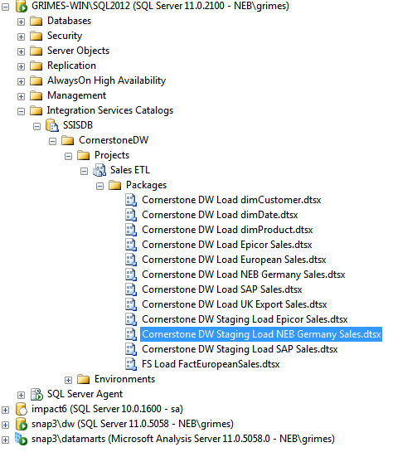

* 1. Go to Connection Managers tab and modify the Excel, *if necessary*, to point to the XLSX file from **Step 2** above.

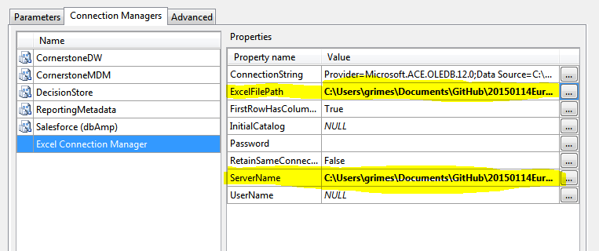

* 1. Click OK to execute the package.

1. Run Cornerstone DW Load NEB Germany Sales.dtsx package.

From SQL Server Management Studio, right-click on the package and select Execute option:

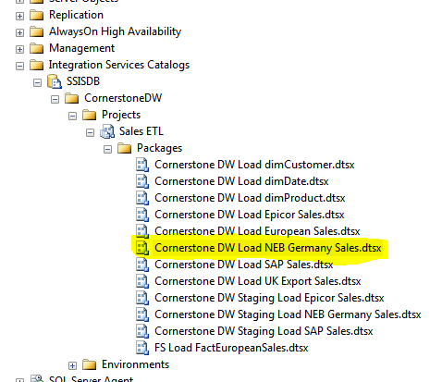

1. Run the last two steps of the “Refresh CornerstoneDW (Full)” job.
   1. Expand SQL Server Agent and right-click on the job.
   2. Select “Start Job at Step” option:

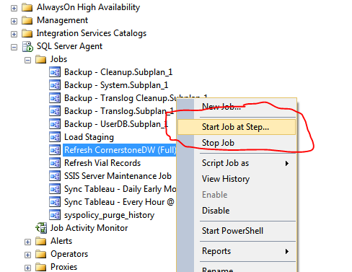

* 1. Select Step #7, “Refresh OLAP Cubes” and click Start

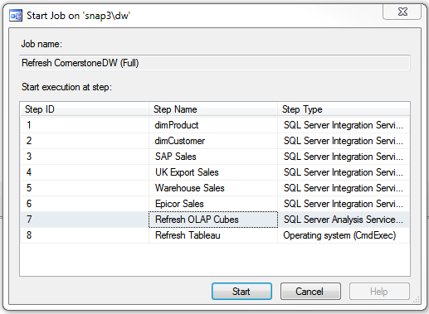

* 1. Verify that the job succeeded (takes approx. 25 min).
     1. From SQL Server Agent, right-click on the job and select View History option.
     2. The resulting window should show successful completion

